Universidad de Cundinamarca
Lengua Extranjera II

Lesson 1 - chapter 1: apollo speaks

Cristian Esteban Ruiz Parra

30 de septiembre de 2025

COMPREHENSION QUESTIONS
- Where was the Priestess sitting?
- On a three-legged chair on top of a very large rock.
- What was the question the King asked the Priestess?
- He asked if he and his wife would have a son who would one day be king.
- What came out of the opening in the rock?
- Something like white smoke, which was Apollo’s message.
- Why must the King be careful of Danae’s son?
- Because one day he would kill the King.
- How can the King stop this from happening?
- By killing his daughter himself.
- What do the gods do to people who kill their own family?
- They punish them.
- Why couldn’t Acrisius kill Danae?
- Because he was afraid of the gods.
- How did the King feel when he left the Priestess?
- More unhappy than before he arrived.
- What kind of woman was Danae?
- She was a very beautiful girl.
- How could the King stop his daughter from having a son?
- By locking her away so she could never meet a man.
TOPICS FOR DISCUSSION
- What do you think the King has decided to do?
- He probably decided to lock Danae up to prevent her from having a child.
- Can you name any other ways that the ancient Greeks used to predict the future?
- Yes, I know two ways, one is the interpretation of dreams, and the other is the interpretation of the stars.
- Describe the “ideal” father.
- An ideal father protects, guides and supports his children, and does not harm them.
- What question would you ask the Priestess if you had the chance?
- What can I do to achieve all my dreams and goals?
ACTIVITIES
- Complete the conversation between King Acrisius and the Priestess.
Priestess: What is it you wish to know?
King Acrisius: I want to know if I will have a son who will be king.
Priestess: You will not have a son, but your daughter will.
King Acrisius: How can I stop this from happening?
Priestess: The only way is to kill your daughter.
King Acrisius: But the gods punish those who kill their own family.
- Match the gods and goddesses to their descriptions.
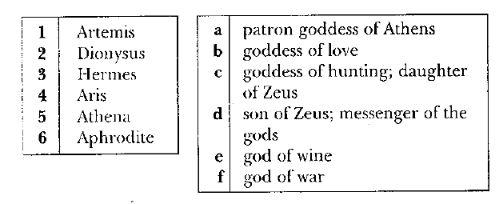
1. __c__ 2. __e__ 3. __d__ 4. __f__ 5. __a___ 6. __b__
C. Find the missing word to complete the pairs.
2. priest = priestess
3. son = daughter
4. king = queen
5. waiter = waitress
6. actor = actress
VOCABULARY EXERCISES
Fill in the gaps with the correct word from the box.
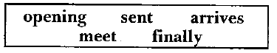
1. We decided to __meet__ at the school entrance.
2. After hours of searching, we __finally__ found the keys in a drawer.
3. I could see them talking in the other room through a(n) __opening__ in the wall.
4. "The train from Bristol __arrives__ in ten minutes," said the announcer.
5. Lucy __sent__ me a beautiful postcard from her Caribbean holidays.
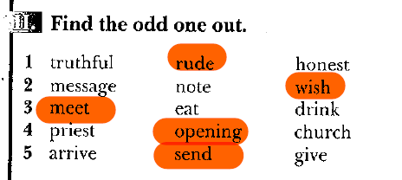

Fill in the correct form of the words in capitals.
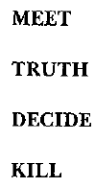
1. We had a company meeting to decide about the new advertisement.
2. "You must give me a truthful answer," said the judge.
3. You must think first, before you make a decision.
4. We saw a giant killer whale, or as it is called an orca, at the aquarium.

